ASME SRIT Student Section and Team Garudans Achievements 2022-2023

|  |  |  |  |  |  |  |
| --- | --- | --- | --- | --- | --- | --- |
| 01 | 2022 | SAE INDIA BICYCLE DESIGN COMPETITION 2021 | SAE INDIA | 21,22/05/2022 at Bannari Amman Institute of Technology, Erode | 12000 | Best Dyanmic Performance |
| 02 | 2022 | Indian Karting Racing (Season 6) | ISIE India | January - 2022 Galgotias University, Noida, Uttar Pradesh | 40000 | Best Acceleration Award – 10,000/-Best Innovation Award- 10,000/- Future Award- 10,000/- |
|  | | | | | | |
| 03 | 2022 | IAM3D Desigfn Presentation Compettion | ASME EFX | 08-12-2022 at Ramaiah Institute of Technology | 8000 | Fist Prize |
|  | | | | | | |
| 04 | 2022 | Electric vehicle design Compettion | SAE INDIA | 21.3.2022 to 25.03.2022 at Bannariamman Institute of Technology | 2000 | Second Prize |
|  | | | | | | |
| 05 | 2022 | National level technical symposium | Automobile Department | 24.03.2022 at Hindushtan Institute of Technology | 1000 | Mr.Mechanic First Prize |
|  | | | | | | |
| 06 | 2022 | National level technical symposium | Automobile Department | 24.03.2022 at Hindushtan Institute of Technology | 300 | Paper presentation Third Prize |
| 07 | 2022 | National level technical symposium | Mechanical Department | 7.05.2022 at SONA College of Technology | 600 | Paper presentation Second Prize |
| 08 | 2022 | National level technical symposium | Automobile Department | Yugam 19. 5. 2022 at Kumaraguru College of Technology | 1000 | Paper presentation Second Prize |
| 09 | 2023 | Formula Kart Racing Championship 01 | RACY Club | 1st - 2nd February 2023  at  Kari Motors Speedway | 48000 | Overall Runner-up Championship Award – 30,000/- Best SkidPad Award – 3,000/- Best Autocross Award – 3,000/- Best Innovation Award - 3,000/- Light Weight Award - 3,000/-Best Build Quality Award -3,000/- Best Virtual presentation Award - 3,000/- Best Cost optimum Award Go-Green Award Best Female Award |
|  | | | | | | |
| 10 | 2023 | Medicnik 2k23 | Department of Biomedical engineering | 20.02.2023 at Karpagam Academy of Higher Education. | 1500 | Second Prize |
| 11 | 2023 | Yugam | Yugam | 4.03.2023 Kumaraguru College of Technology | 10000 | Third Prize |
| 12 | 2023 | National level technical symposium | Mechanical Department | 16.02.2023 at KPR Institute of engineering and Technology | 1500 | Paper presentation Second Prize |
| 13 | 2023 | National level technical symposium | Mechanical Department | 24.03.2023 at Hindustan college of engineering and Technology | 500 | Paper presentation Second Prize |
| 14 | 2023 | Live design hackathon | ASMEEFX & Autodesk | 1.4.2023 at PES University Bangalore | 20000 | Second Prize |
| 15 | 2022 | Student Attendance Ratio Challenge | ASME Efests | 25.03.2022 Virtual | 500 USD | First Prize |
| 16 | 2022 | Extended Reality Challenge | ASME Efests | 25.03.2022 Virtual | 400 USD | First Prize and Second Prize |
| 17 | 2023 | Extended Reality Challenge | ASME Efests | 25.03.2023 Virtual | 75 USD | Third Prize |
| 18 | 2023 | Student Attendance Ratio Challenge | ASME Efests | 25.03.2023 Virtual | 500 USD | First Prize |
| 19 | 2022 | Scavenger Hunt | ASME E-Fest Careers | 12.11.2022 Virtual | 200 USD | Various Prizes |
| 20 | 2023 | Autonomous Drone Development Competition 2023 | SAE India  At KCG College of Technology Chennai | 26/08/2023 | - | 13th Rank in India |
|  | | | | | | |
| 21 | 2023 | ASME- Student section | ASME India | 2022-2023 | Rs.10,000/- | Distinguished Student section India |
| 22 | 2023 | ASME- Student section | ASME India | 2022-2023 | - | Star Chair Awardee Mr.E.Raghunath |
| 23 | 2023 | Techgium | L&T Technology | 2022-2023 |  | Semifinalist and 4 Students going for Placement opportunities |
| 24 | 2023 | ASME IDETC-CIE 2023 | ASME | 22/08/2023 | $50 | Fee waiver Award |
| 25 | 2023 | Kart Racing Championship | AIMS Academy | 06-07/08/2023 | - | 1. Best safety Award, 2. Dr.Radha Krishnan Award |
| E:\24-25 ODD Sem\achievements\Group.jfif | | | | | | |
| A fund of Rs.5, 00,000 was received as Product Development Fund on  15/07/2019 from India Innovation Challenge Design Contest (IICDC)  conducted by Texas Instruments in collaboration with Department of Science  and Technology (DST), powered by AICTE, Supported by My Gov. The fund  was provided to the Project titled, ‘Smart Fishing Boat’ A cash Prize of Rs.25,  000 was received from Department of Science and Technology (DST), for  more number of Patents filed during the academic year. The following were the  student participants of our Institution  • Ms.Preethi of final year IT department  • Mr.N.Ravinder Kumar of final year Mechanical  • Mr.S.Monish of final year Mechanical  • Mr.N.Rudresh of final year Mechanical | | | | | | |
| * In the mid March of 19th 2020 Pezray Technologies conducted the Product Launch of Fish Cutting Machine providing live demo to the gathering. Dr. Paulraj, Principal of Sri Ramakrishna Institute of Technology revealed the machine by cutting the ribbons. | | | | | | |
| 1. Sri Ramakrishna Institute of Technology continues to shine in the prestigious ASME Student Competitions!  The latest ASME Competition leaderboard for the academic years 2022-2023 has been released, and our esteemed institution has secured remarkable positions globally!  Overall Leaders: 1st Position our students have accumulated the most points through their exceptional 1st, 2nd, and 3rd place finishes, propelling Sri Ramakrishna Institute of Technology to the top of the leaderboard! Best Designers and Builders: 1st Position Showcasing their innovative designs and unparalleled problem-solving skills, our talented students have been recognized as the best designers and builders worldwide! Best Communicators: 4th Position With their outstanding communication abilities and impressive presentation skills, our students have secured the 4th position in the Best Communicators category. These remarkable achievements are a testament to the unwavering dedication, hard work, and innovative spirit of our students and faculty. We take immense pride in their accomplishments and their contribution to advancing the field of engineering. Join us in congratulating our exceptional students and faculty for their remarkable achievements on the global stage. Their success fuels our commitment to continuing excellence in engineering education and fostering a nurturing environment for future leaders. | | | | | | |
| Team Simba XRC Autonomous Vehicle Race Team secured Third place globally.  E:\24-25 ODD Sem\KPI upto June 2024\KPI_PROOFS\1710685584066.jpg | | | | | | |
|  | | | | | | |

National level Technical symposium

Paper presentation organized by department of automobile in Hindustan college of engineering and Technology. (24.03.2023)

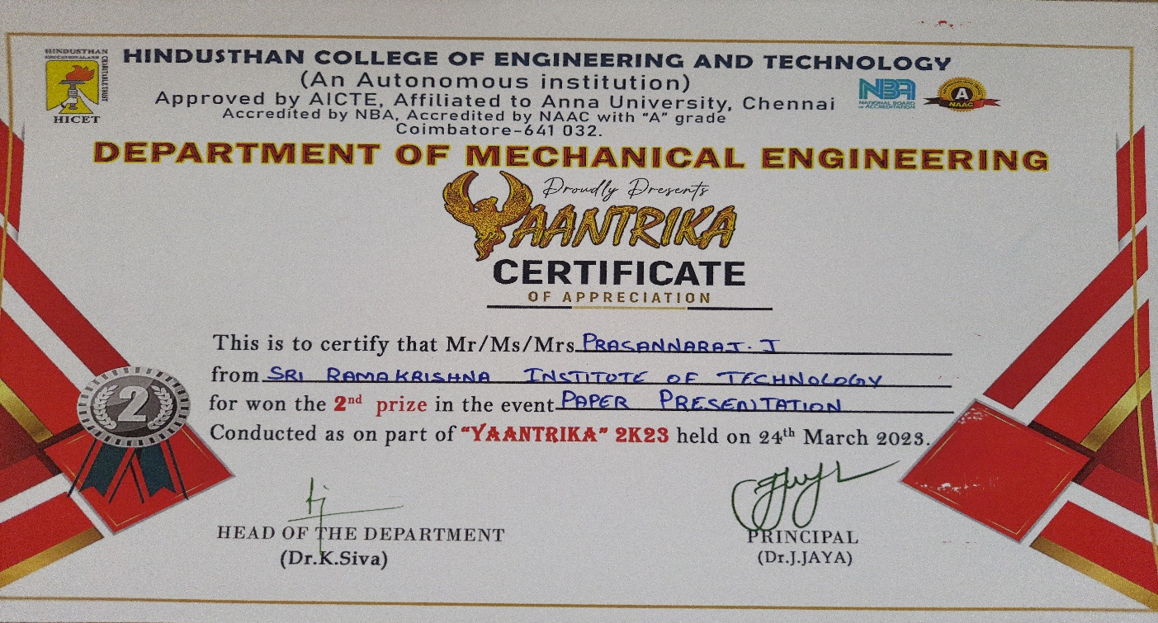

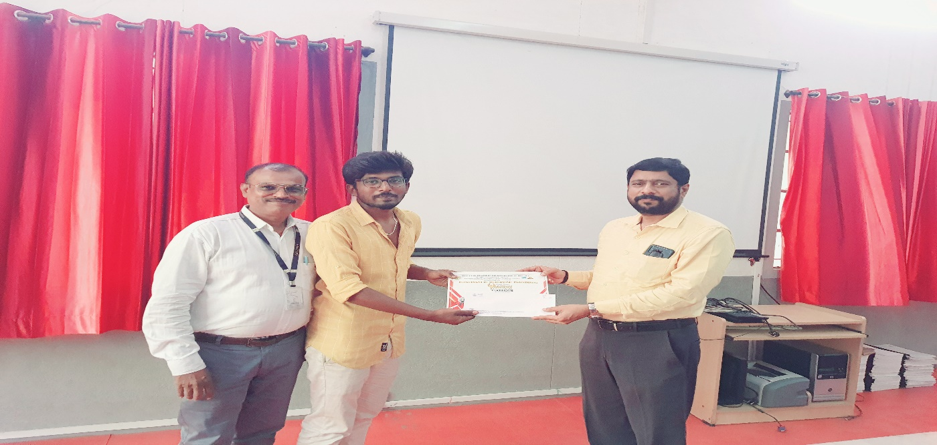

Paper presentation organized by department of Mechanical Engineering in KPR college of engineering and Technology. (16.02.2023)





